Multi-Vendor E-Commerce Web App with LLM Integration

*UNDERTAKEN BY*

## Asad jillani F22BINFT1E02074

**Fall 2022 – 2026**

*SUPERVISED BY*

## Dr.muhammad Asadullah



A DISSERTATION SUBMITTED AS PARTIAL FULFILLMENT OF THE REQUIREMENTS

FOR THE DEGREE OF Bachelor of Science Engineering

# DEPARTMENT OF INFORMATION TECHNOLOGY

**The Islamia University of Bahawalpur-PAKISTAN**

**SESSION Fall 2022 – 2026**

## Content table

**Chapter 1: Introduction**

* 1. Introduction 3
  2. System Overview 3
  3. Objective 4
  4. Problem Definition 5
  5. Project Scope 5
  6. Advantages 6

**Chapter 2: Proposed System**

* 1. Detail Description of Proposed System 6
  2. Hurdles to Optimize the Examination Process 9
     1. Minimize 9
     2. Maximize 10

**Chapter 3: System Design**

* 1. Unified Modeling Language 10
  2. Use Case Diagram 11
     1. Actor 11
     2. Use Case 12
     3. When to Use: Use Case Diagram 12
  3. Sequence Diagram 17
  4. Activity Diagram 21
  5. Collaboration Diagram 24

**Chapter 4: User’s Guide**

* 1. User Guide 26

***Online E-Commerce Store***

### Introduction

In today's digital age, e-commerce has revolutionized the way consumers shop, offering unparalleled convenience, variety, and accessibility. Our project aims to develop a comprehensive e-commerce shopping platform that caters to the diverse needs of modern consumers while providing a seamless and engaging shopping experience.

The primary objective of this project is to create an intuitive online marketplace that connects buyers and sellers across various product categories, including fashion, electronics, home goods, and more. By leveraging cutting-edge technology and user- centric design principles, we aim to build a platform that not only facilitates transactions but also fosters community engagement and customer loyalty.

# Key features of our e-commerce platform will include:

### System Overview

Shopping E-Commerce is built on Python, MYSQL server. The Web application is built to serve the following areas:

* + 1. **User -Friendly Interface**: A clean and responsive design that ensures easy navigation and a pleasant shopping experience on both desktop and mobile devices.
    2. **Advanced Search and Filtering**: Robust search functionality and filtering options that allow users to quickly find products based on their preferences, such as price range, brand, and ratings.
    3. **Secure Payment Gateway**: Integration of multiple secure payment options to ensure safe and convenient transactions for users.
    4. **Personalized Recommendations**: Utilizing machine learning algorithms to analyses user behaviors and preferences, providing tailored product suggestions that enhance the shopping experience.
    5. **Customer Reviews and Ratings:** A system for customers to leave feedback and ratings, helping future buyers make informed decisions and fostering trust within the community.
    6. **Order Tracking and Management**: Real-time order tracking and easy management of purchases, returns, and exchanges to enhance customer satisfaction.
    7. **Promotions and Discounts:** Implementation of promotional campaigns, discount codes, and loyalty programs to incentivize purchases and encourage repeat business.
    8. **Seller Dashboard**: A dedicated interface for sellers to manage their inventory, track sales, and analyze performance metrics, empowering them to optimize their offerings.

### Objective

The primary objective of an e-commerce shopping platform is to enhance the overall customer experience by providing a seamless and user-friendly interface that simplifies the shopping process. By offering a diverse range of products and effective search functionalities, the platform aims to attract a broad audience and increase sales and revenue. Security is paramount; therefore, implementing robust payment gateways ensures safe transactions, fostering trust among users. Additionally, the platform seeks to leverage data analytics to gain insights into consumer behavior, allowing for personalized marketing strategies that resonate with individual preferences. Engaging customers through reviews and community features further strengthens brand loyalty and encourages repeat business. The platform also supports sellers by providing them with tools to manage inventory and track performance effectively. By staying agile and responsive to market trends, the e-commerce site can adapt to changing consumer demands and technological advancements.

Ultimately, the goal is to create a dynamic marketplace that benefits both buyers and sellers while promoting sustainable practices. Through these efforts, the platform aspires to establish itself as a trusted leader in the online shopping landscape.

Create a Web application to be used in place of old paper-based user examination process.

 Use Python and MYSQL Server technology to create strong and secured database connectivity.

 Incorporate the server software within the code.

 Runtime package and deployment instructions are given.

Broad based objectives are

 Reduce the cost  Reduce the time

 Reduces Paper Work

### Problem Definition

The problem definition for our e-commerce shopping platform revolves around addressing the challenges faced by both consumers and sellers in the online marketplace. Consumers often encounter difficulties in navigating cluttered interfaces, leading to frustration and abandoned carts. Additionally, concerns about payment security and product authenticity can deter potential buyers. For sellers, managing inventory and understanding customer preferences can be complex without the right tools and insights. Our platform aims to resolve these issues by creating a streamlined, secure, and user- friendly environment that enhances the shopping experience for all stakeholders involved.

### Project Scope

The project scope for the e-commerce shopping platform includes the development of a user-friendly interface that enhances navigation and shopping experiences across devices. It encompasses robust product catalog management, allowing sellers to easily

upload and manage their inventory. The platform will feature advanced search and filtering options, secure payment processing, and customer account management for personalized experiences. Additionally, it will implement a review and rating system to foster community engagement and provide analytics tools for sellers to track performance. Overall, the scope aims to create a scalable and comprehensive marketplace that addresses the needs of both consumers and sellers effectively.

### Advantages

* + 1. **Convenience**: E-commerce platforms allow customers to shop anytime and anywhere, eliminating the need to visit physical stores and providing a hassle-free shopping experience.
    2. **Wider Reach**: Businesses can reach a global audience, expanding their market beyond geographical limitations and attracting diverse customer segments.
    3. **Cost-Effectiveness**: Operating an online store often incurs lower overhead costs compared to a physical storefront, allowing businesses to offer competitive pricing and promotions.
    4. **Personalization**: E-commerce platforms can leverage data analytics to provide personalized shopping experiences, recommending products based on user behavior and preferences, which can enhance customer satisfaction and loyalty.
    5. **Inventory Management:** Advanced inventory management tools help sellers track stock levels in real-time, reducing the risk of overstocking or stockouts and improving overall operational efficiency.
    6. **Scalability**: E-commerce platforms can easily scale to accommodate growing business needs, whether through expanding product lines, increasing website traffic, or entering new markets.

### Detail Description of Proposed System

The proposed e-commerce system aims to create a comprehensive online shopping platform that enhances the shopping experience for consumers while providing robust tools for sellers. Below is a detailed description of the key components and functionalities of the proposed system:

#### User Interface and Experience (UI/UX)

* + **Responsive Design**: The platform will feature a responsive design that adapts seamlessly to various devices, including desktops, tablets, and smartphones, ensuring a consistent user experience across all platforms.
  + **Intuitive Navigation**: A well-structured menu and clear categorization of products will allow users to navigate the site easily. Breadcrumbs and search bars will enhance usability.
  + **Visual Appeal**: High-quality images, engaging product descriptions, and a clean layout will create an attractive shopping environment that encourages exploration.

#### Product Catalog Management

* + **Dynamic Product Listings**: Sellers can easily upload and manage their products, including images, descriptions, prices, and stock levels. The system will support bulk uploads for efficiency.
  + **Product Variations**: The platform will allow sellers to offer product variations (e.g., size, color) within a single listing, simplifying the shopping experience for customers.
  + **Inventory Tracking**: Real-time inventory management will help sellers monitor stock levels, receive alerts for low inventory, and automate reordering processes.

#### Search and Filtering Capabilities

* + **Advanced Search Functionality**: Users can search for products using keywords, and the system will provide autocomplete suggestions to enhance search efficiency.
  + **Filtering Options**: Customers can filter search results based on various criteria, such as price range, brand, ratings, and availability, allowing for a more tailored shopping experience.

#### Personalization Features

* + **Recommendation Engine**: The system will utilize machine learning algorithms to analyze user behavior and preferences, providing personalized product recommendations based on past purchases and browsing history.
  + **Wish Lists**: Customers can create and manage wish lists, allowing them to save products for future consideration and share them with friends and family.

#### Secure Payment Processing

* + **Multiple Payment Options**: The platform will integrate various secure payment gateways, including credit/debit cards, digital wallets, and bank transfers, to accommodate diverse customer preferences.
  + **SSL Encryption**: All transactions will be secured with SSL encryption to protect sensitive customer information and build trust.

#### Order Management and Tracking

* + **Order Processing**: The system will automate order processing, including order confirmation, payment processing, and shipping notifications, streamlining the fulfillment process for sellers.
  + **Real-Time Order Tracking**: Customers will have access to real-time tracking of their orders, providing transparency and reducing inquiries related to order status.

#### Customer Reviews and Ratings

* + **Feedback System**: Customers can leave reviews and ratings for products, helping future buyers make informed decisions and fostering a sense of community.
  + **Moderation Tools**: Sellers will have access to moderation tools to manage reviews and respond to customer feedback, enhancing engagement and trust.

#### Promotional and Marketing Tools

* + **Discount and Coupon Management**: Sellers can create and manage promotional campaigns, including discount codes and seasonal sales, to attract customers and boost sales.
  + **Email Marketing Integration**: The platform will support email marketing campaigns, allowing sellers to reach out to customers with personalized offers and updates.

#### Analytics and Reporting

* + **Dashboard for Sellers**: A comprehensive analytics dashboard will provide sellers with insights into sales performance, customer behavior, and inventory management, enabling data-driven decision-making.
  + **Customer Insights**: The system will track customer interactions and preferences, allowing businesses to tailor their marketing strategies effectively.

#### Customer Support Features

* + **Multi-Channel Support**: The platform will offer various customer support options, including live chat, email support, and a comprehensive FAQ section, ensuring that users can easily get assistance.
  + **Help Center**: A dedicated help center will provide resources, guides, and tutorials to assist customers in navigating the platform and resolving common issues.

#### Scalability and Future Enhancements

* + **Modular Architecture**: The system will be built on a modular architecture, allowing for easy integration of new features and third-party services as the business grows.
  + **API Integration**: The platform will support API integrations with other systems, such as inventory management software, CRM tools, and shipping providers, enhancing operational efficiency.

#### Sustainability Features

* + **Eco-Friendly Options**: The platform will promote eco-friendly products and practices, appealing to environmentally conscious consumers and supporting sustainable business practices.

### Hurdles to Optimize the Examination Process

Developing the ***Shopping E-Commerce*** was not an easy thing to do as we were facing the following challenges.

### Minimize

* + - * Cost of Entire Process.
      * Total Time Required.
      * Human Involvement.
      * Data Redundancy.
      * Paperwork.

### Maximize

* + - * Availability.
      * Transparency.
      * Accuracy.
      * Reliability.
      * Productivity.

The challenge to the IT professionals today, is to efficiently develop and deploy distributed application for use on both Corporate Intranet and over the Internet. Companies that can do this effectively will gain strategic advantages in the information economy.

## Unified Modeling Language

“The Unified Modeling Language (UML) is a language for specifying, visualizing, and constructing the art facts of software systems as well as for business modeling”.

This is the advanced method of showing the logical design of the system. In this tool of logical design, we show the design of the system through the use of many diagrams. Visual Modeling is a way of thinking about problems using models organized around read world ideas. Models reduce the amount of time it takes to learn and it improves safety, performance and consistency and to reduce errors. It communicates effectively with process, maps, charts and diagrams of all types.

The UML offers standard semantic and notations for describing object structure and behavior and have emerged as design medium of choice for developing large scale distributed object applications. Rational unified process an extensive set of software development guidelines and rational rose visual modeling tool, the UML, greatly facilitate.

The UML notation is useful for graphically depicting the object-oriented analysis or design model. It not only allows specifying system requirements and capturing design decisions, but also promotes communication among key persons involved in the development effort. Rational Rose supports the majority of these models as follows:

* Use Case Diagram
* Sequence Diagram
* Collaboration Diagram
* Component Diagram
* Activity Diagram
* Class Diagram

## Use Case Diagram

The main ingredients for this type of diagram are use cases and actors, respectively the roles that users can take towards a system. It is often used in early stages of design process to collect the intentional requirements of a project. This diagram shows the overall functionality of the system.

Use Case diagrams show the interaction between use cases, which represent system functionality, and actors, which represent the people or systems that provide or receive information from the system. Use cases represent the requirements of the system from the user’s perspective. So, use cases are the functionality that the system provides. Actors are the administrator, test conductor and the user of the system. Use cases describe that is inside the system scope.

## Actor

An Actor is anyone or anything that interacts with the system being built.



## Use Case

Use Case is a high-level piece of functionality that the system will provide. In other words, a use case illustrates how an actor might use the system.

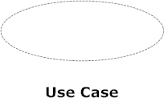

## When to Use: Use Case Diagram

Use cases are used in almost every project. These are helpful in exposing requirements and planning the project. During the initial stage of a project most use cases should be defined, but as the project continues more might become visible.

Uses Case diagrams are used to analyze and illustrate the functionality of the system. They show the process flow – the steps taken by users to perform a specific function.Use Case diagram are also frequently used to illustrate test cases for quality assurance. Because Use Case diagrams are so effective in illustrating process flow they are also very effective in validating that a process flow works correctly.

**Product Use Case Diagram**

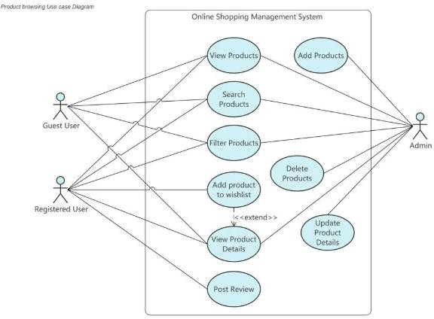

**Shopping Cart Use Diagram**

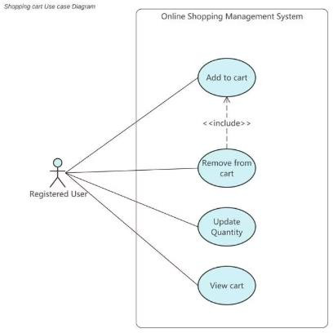

**Order Placement Use Case Diagram**

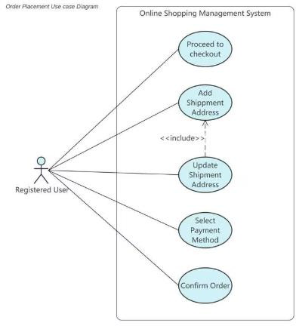

**Order History Use Case Diagram**

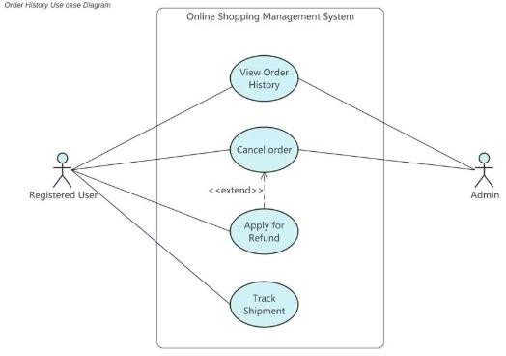

**Customer Support Use Case Diagram**

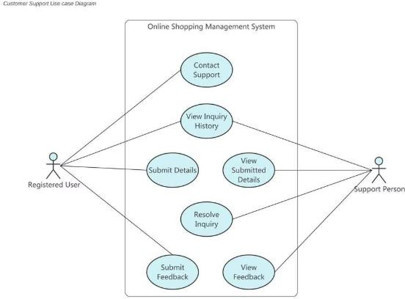

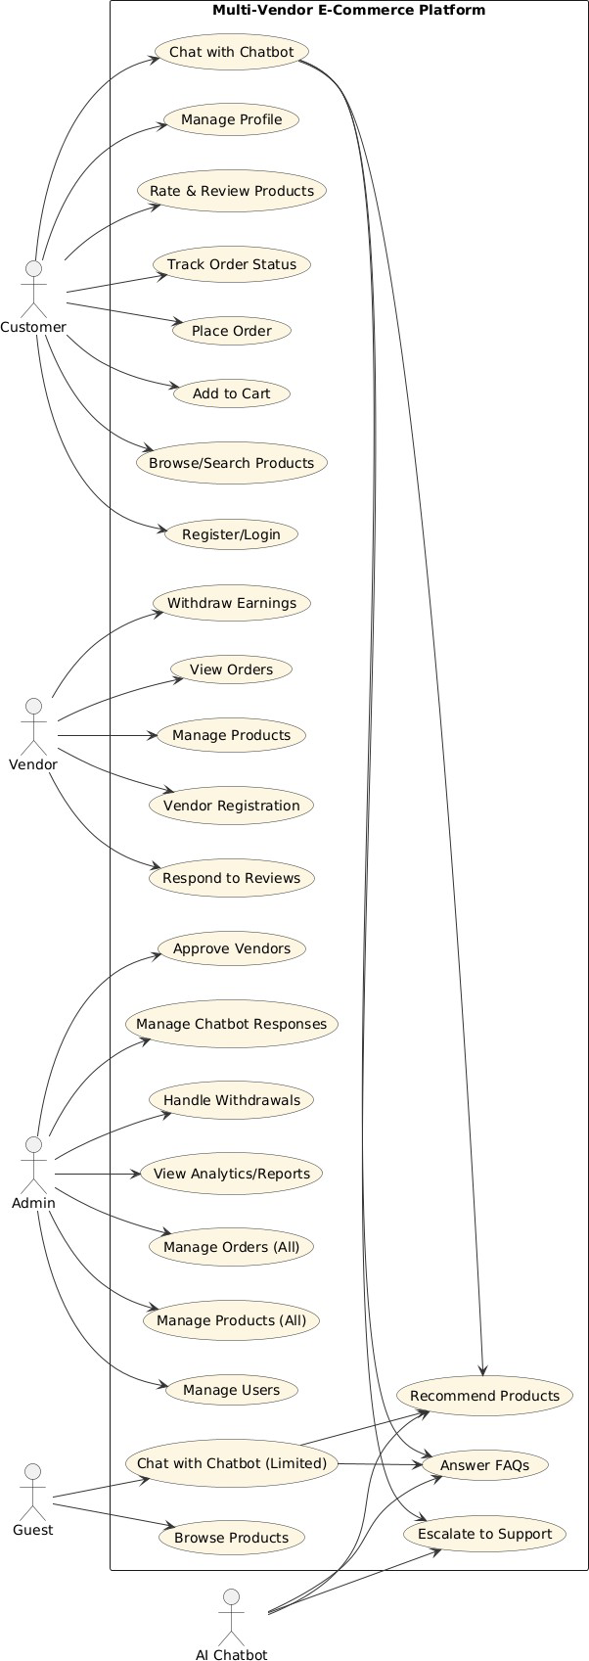

## Sequence diagram

UML sequence diagrams are used to represent or model the flow of messages, events and actions between the objects or components of a system. Time is represented in the vertical direction showing the sequence of interactions of the header elements, which are displayed horizontally at the top of the diagram.

Sequence Diagrams are used primarily to design, document and validate the architecture, interfaces and logic of the system by describing the sequence of actions that need to be performed to complete a task or scenario. UML sequence diagrams are useful design tools because they provide a dynamic view of the system behavior which can be difficult to extract from static diagrams or specifications.

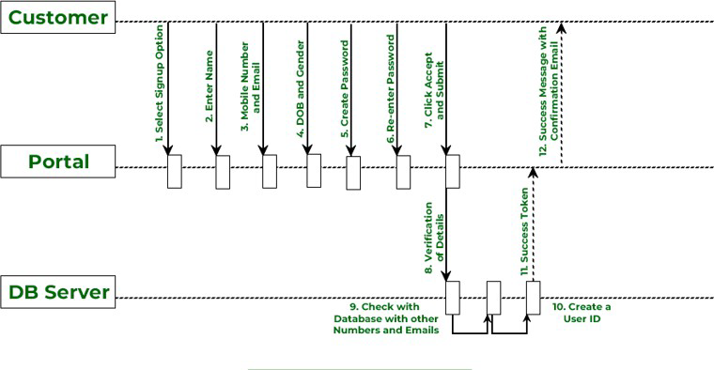

***Sign-up Functionality UML (Sequence Diagram) in E- Commerce***

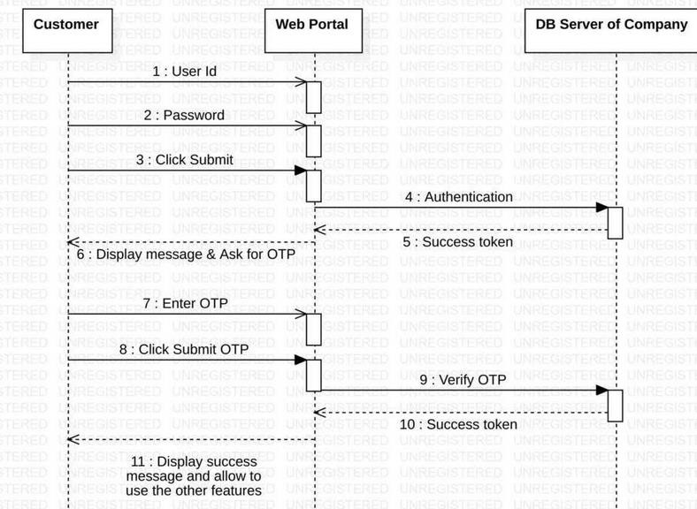

***Login Functionality UML (Sequence Diagram) in E-***

***Commerce***

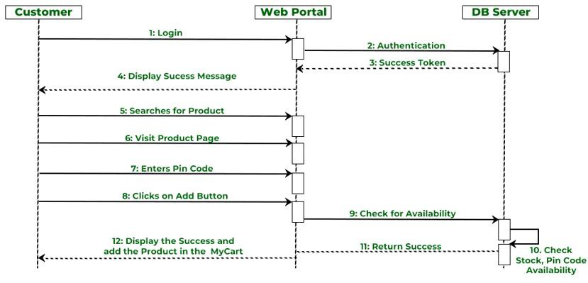

***Add to Cart Functionality UML (Sequence Diagram) in E-Commerce***

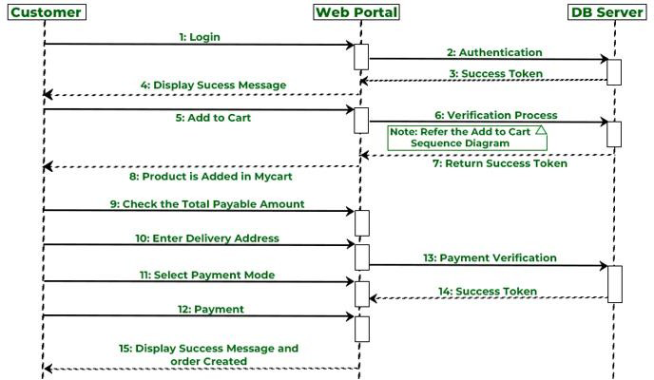

***Product Order Functionality UML (Sequence Diagram) in E-Commerce***

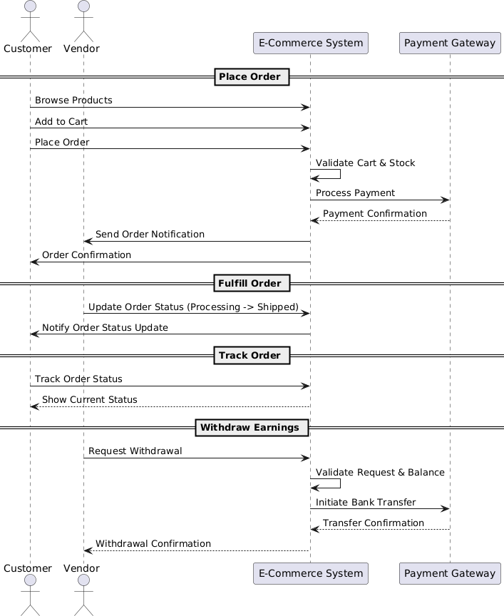

## Activity diagram

The process flows in the system are captured in the activity diagram. Similar to a state diagram, an activity diagram also consists of activities, actions, transitions, initial and final states, and guard conditions. Processes involving different use cases are shown in workflows, e.g., from ordering to delivery and payment. Activity diagrams describe the working behavior of a system.

**User Activity Diagram**

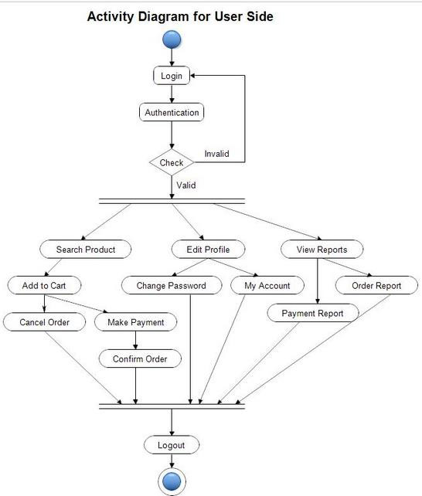

**Admin Activity Diagram**

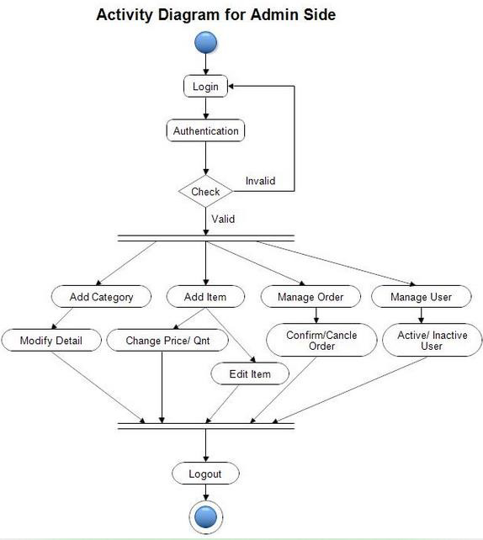

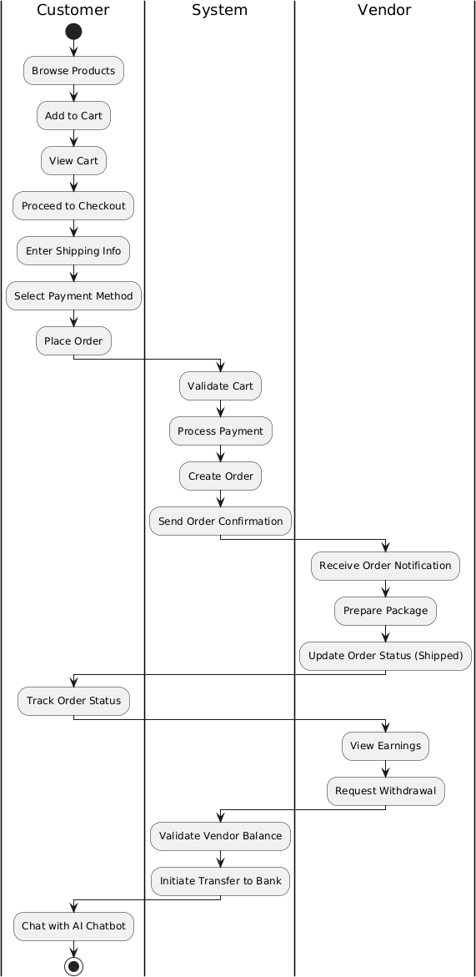

## Collaboration diagram

A collaboration diagram, also called a communication diagram or interaction diagram, is an illustration of the relationships and interactions among [software](http://whatis.techtarget.com/definition/0%2C289893%2Csid9_gci213024%2C00.html) [object](http://whatis.techtarget.com/definition/0%2C289893%2Csid9_gci212680%2C00.html)s in the Unified Modeling Language (UML). The concept is more than a decade old although it has been refined as modeling paradigms have evolved.

A collaboration diagram resembles a [flowchart](http://whatis.techtarget.com/definition/0%2C%2Csid9_gci212134%2C00.html) that portrays the roles, functionality and behavior of individual objects as well as the overall operation of the system in [real time.](http://whatis.techtarget.com/definition/0%2C289893%2Csid9_gci214344%2C00.html) Objects are shown as rectangles with naming labels inside. These labels are preceded by colons and may be underlined. The relationships between the objects are shown as lines connecting the rectangles. The [message](http://whatis.techtarget.com/definition/0%2C289893%2Csid9_gci212552%2C00.html)s between objects is shown as arrows connecting the relevant rectangles along with labels that define the message sequencing.

Collaboration diagrams are best suited to the portrayal of simple interactions among relatively small numbers of objects. As the number of objects and messages grows, a collaboration diagram can become difficult to read. Several vendors offer software for creating and editing collaboration diagrams.

Collaboration involves several kinds of [synchronous](http://searchcio-midmarket.techtarget.com/sDefinition/0%2C%2Csid183_gci213080%2C00.html) communication tools such as:

* Instant messaging
* Group chat
* Buddy list and other presence awareness technology
* Whiteboard collaboration
* Application sharing
* Desktop sharing
* Co-browsing
* Voice over IP
* Video and audio-conferencing tools
* 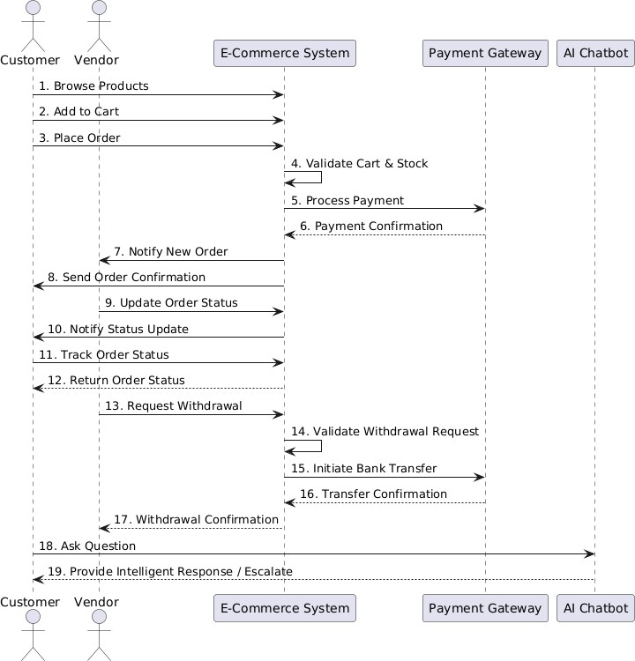

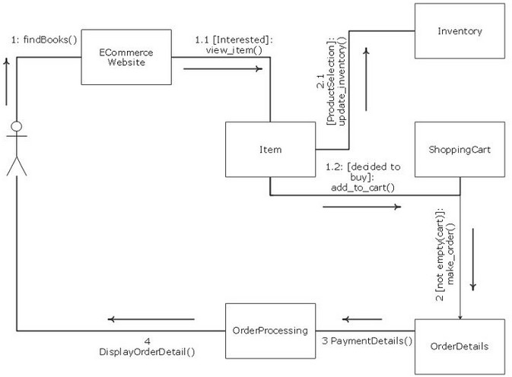

***For admin collaboration Diagram***

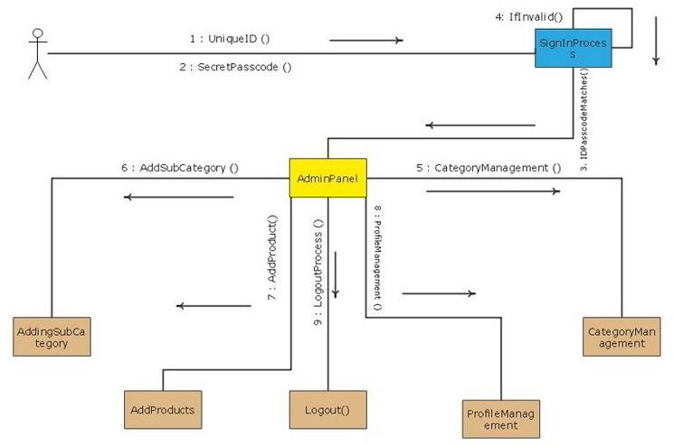

### User Guide



